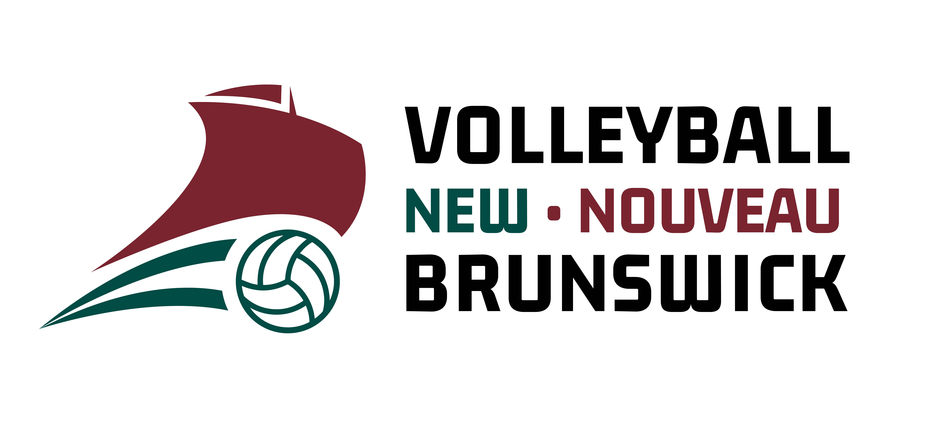

‎**Official Offer Letter**

Hello __________________________________________________,

(athlete name)

We think you have what it takes to ‎be a member of the:

___________________________________________________________

(club name & age category)

This offer is valid until ???(time) on September ????. Please reply within that timeframe to secure your spot on the team.

Please be aware that by accepting this offer, you will forfeit your opportunity to accept an offer, or tryout for another club.

One of the main objectives of the Tryout Period is to‎‎ provide players and families with an opportunity to gather information about volleyball opportunities in their community and time to make an informed decision. With that in mind, we want you to be sure you are choosing the club you feel will provide you with the best volleyball experience‎ so please reach out with questions and only respond if you are certain.

For more information about the Tryout Period please contact Darcy McKillop, Director of Operations, Volleyball NB ([operationsdirector@volleyballnb.org](mailto:operationsdirector@volleyballnb.org))

Congratulations!

_________________________________­­­­­­­­­­_______________

(Coach name)

I accept the offer:

_________________________________­­­­­­­­­­_______________

(Player signature)